# Experiment No.10

**Aim**: To study and implement deployment of Ecommerce PWA to GitHub Pages.

# Theory:

### GitHub Page: GitHub Pages is a free service offered by GitHub that allows developers to host static websites directly from a GitHub repository. It is widely used for hosting portfolios, documentation, project pages, and Progressive Web Applications (PWAs).

**Features:**

1. Hosts static content from the GitHub repository.
2. Automatically deploys upon each push to the repository.
3. Supports Jekyll for static site generation.
4. Offers custom domain configuration with simple DNS setup.

**Reasons for using GitHub Pages:**

1. Completely free for public repositories.
2. Direct integration with GitHub.
3. Quick setup and deployment.
4. Suitable for deploying Flutter web builds and PWAs.

**Companies using GitHub Pages:**

1. Lyft
2. CircleCI
3. HubSpot

**Statistics:** Used in over 775 company tech stacks and by more than 4400 developers.

**Advantages:**

1. Easy to set up for users familiar with GitHub.
2. Native support for static site generators like Jekyll.
3. Custom domain support using a CNAME file.
4. No command-line tools required for basic deployments.

**Disadvantages:**

1. The website's code must be public unless a paid private repository is used.
2. Limited plugin support when using Jekyll.
3. Historically lacked HTTPS support for custom domains (now available when using GitHub’s DNS).

# Link to our GitHub repository: [sadneya145/acti_web](https://github.com/sadneya145/acti_web)

**Github Screenshot:**





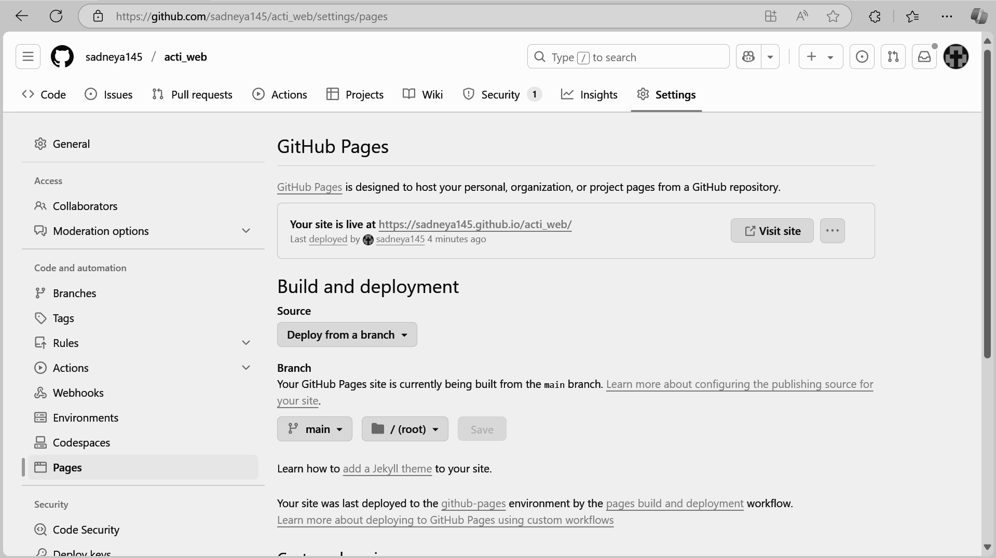

## Conclusion: We successfully studied and implemented the deployment of an PWA application to GitHub Pages. GitHub Pages proved to be an effective hosting solution for PWAs due to its simplicity, direct GitHub integration, and zero-cost hosting for public repositories. The deployment process demonstrated how developers can quickly publish PWAs without complex server configurations, making it an excellent choice for static PWA projects with limited backend requirements.